**DAILY ONLINE ACTIVITIES SUMMARY**

|  |  |  |  |  |  |  |  |
| --- | --- | --- | --- | --- | --- | --- | --- |
| **Date:** | **25-06-2020** | | | | **Name:** | **B.A.SOHANKUMAR** | |
| **Sem & Sec** | **4TH SEM A** | | | | **USN:** | **4AL18CS013** | |
| **Online Test Summary** | | | | | | | |
| **Subject** | | **---** | | | | | |
| **Max. Marks** | | **---** | | **Score** | | **---** | |
| **Certification Course Summary** | | | | | | | |
| **Course** | **BLOCKCHAIN BASICS** | | | | | | |
| **Certificate Provider** | | | **GLA** | **Duration** | | | **2.5 HOURS** |
| **Coding Challenges** | | | | | | | |
| **Problem Statement: C program to reverse the rows in 2d arrays.** | | | | | | | |
| **Status: EXECUTED** | | | | | | | |
| **Uploaded the report in Github** | | | | **YES** | | | |
| **If yes Repository name** | | | | **LOCKDOWN CODING** | | | |
| **Uploaded the report in slack** | | | | **YES** | | | |

**CERTIFICATION COURSE DETAILS:**

Course: BLOCKCHAIN BASICS

Today I have opted this new course and this course has a video content of 2.5 hours.Completed modules today are Database system,What is Blockchain,Database Vs Blockchain,Role of Intermediaries,Blockchain Cryptography, Blockchain solution,Accounts, blocks, Transactions and Merkle trees.

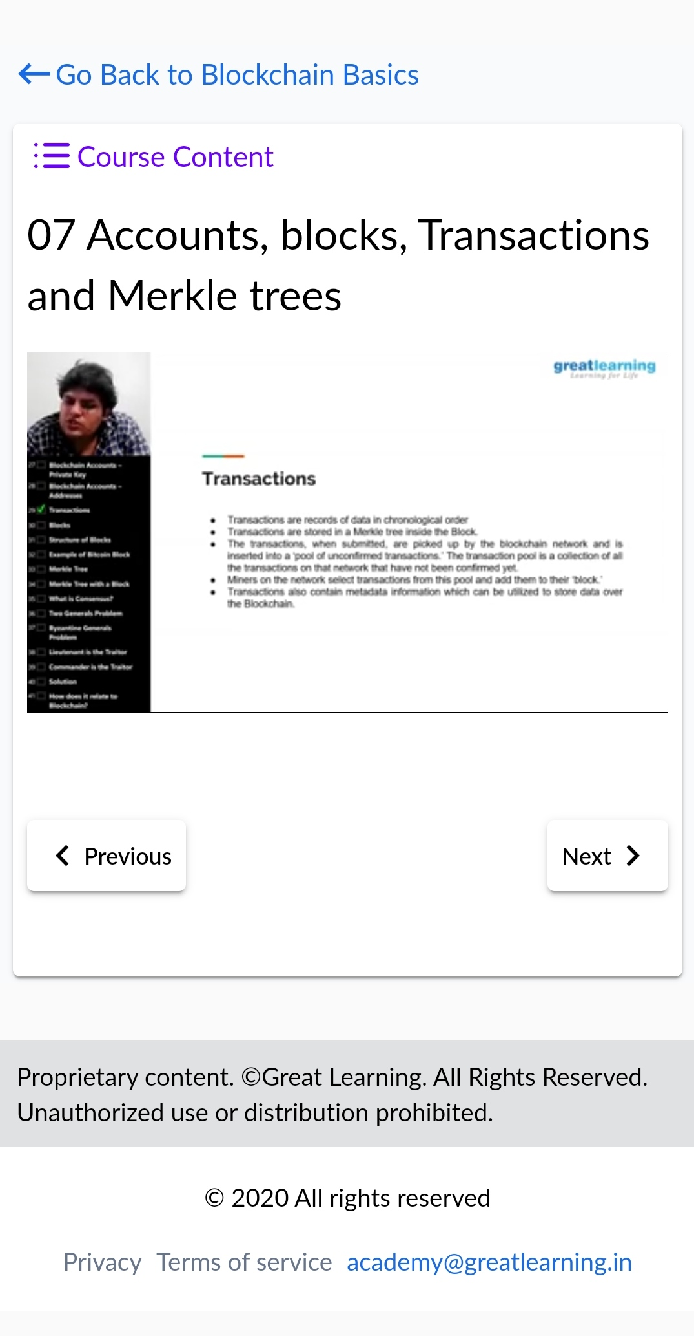 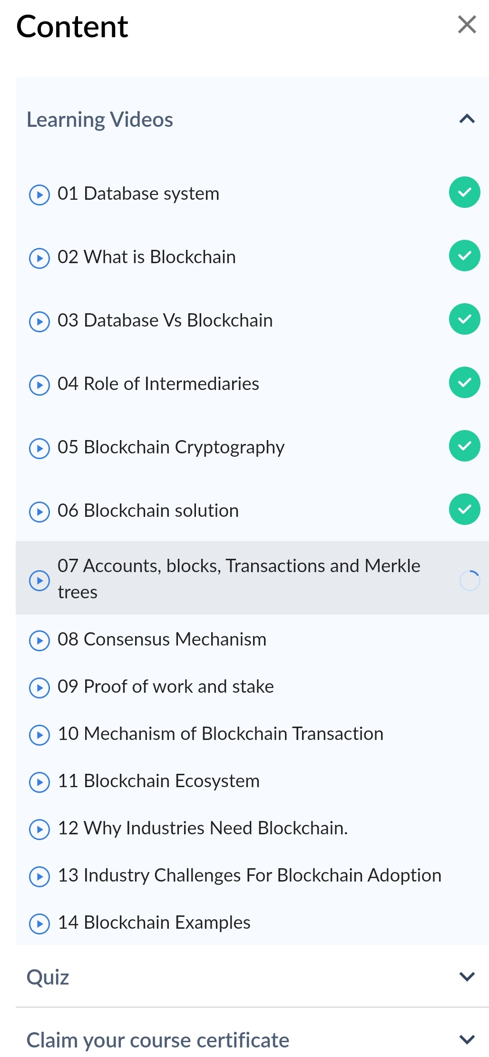

**CODING CHALLENGES DETAILS:**

1 Write a C Program to reverse the rows in a 2d Array.Given a 2D array arr[][] of size M x N integers where M is the number of rows and N is the number of columns. The task is to reverse every row of the given 2D array.

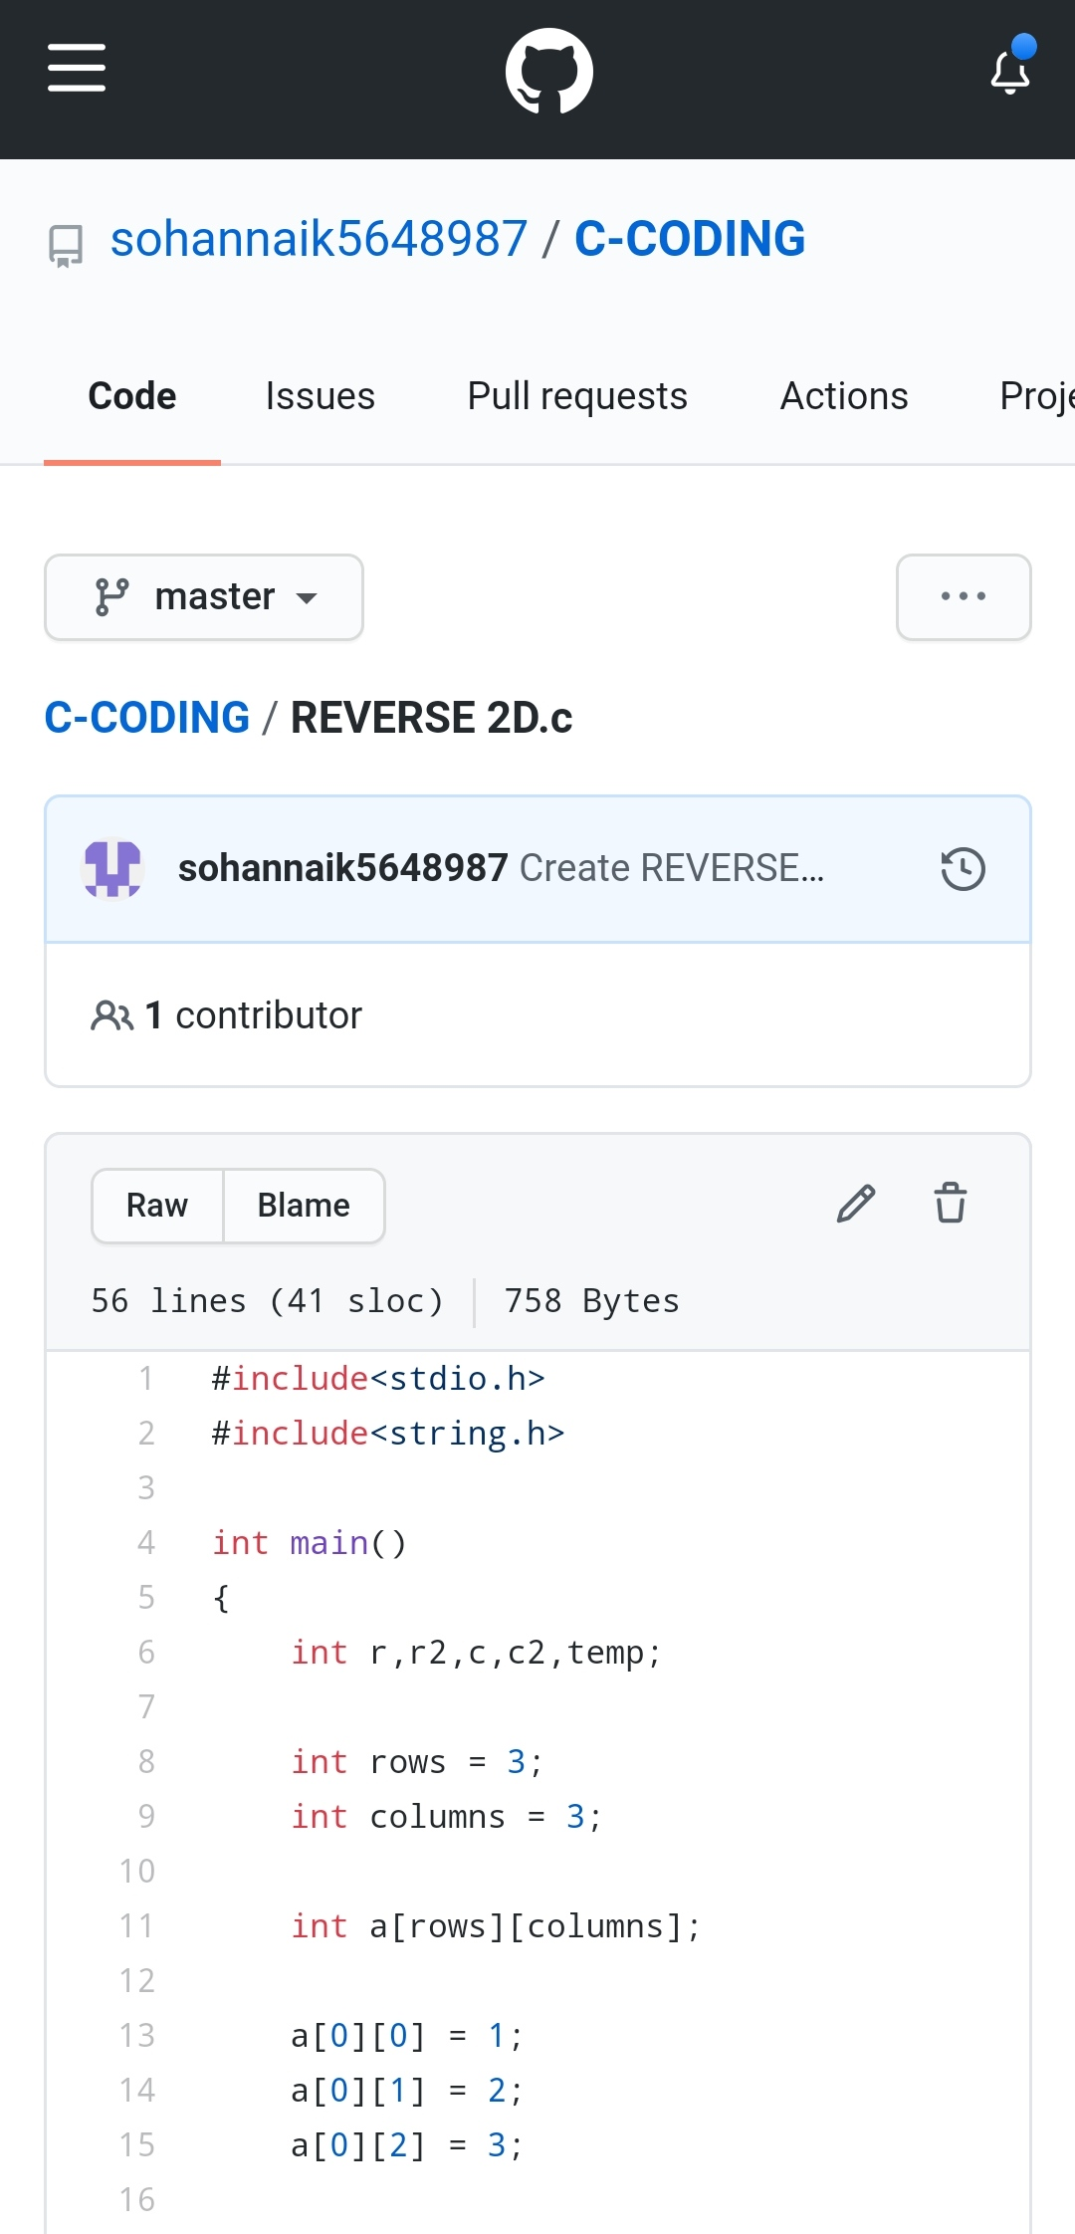

REPOSITORY LINK:https://github.com/sohannaik5648987/C-CODING